Business Plan for Durango Manufacturing Company
Student Name
University
Date

Table of Contents
1. Introduction 3
2. Usefulness of the financial management 3
3. Suggestion on the ways the financial ratios can be used 4
4. Strategy to increase revenue 5
5. Recommendations in increasing operational efficiency 6
6. Recommendations on outsourcing 7
7. Recommendations to reach the revenue goals 11
8. Internal control 13
9. IT deficiencies and ways to overcome it 14
10. Roles and responsibilities of the audit committee member 15
Reference 17

1. Introduction
Business plan forms the blue print of future strategic decisions. The future strategic decisions can vary widely from the strategies intended to be followed and as mentioned in the business plan this happens because most of the time the scenario plays out differently than expected (Stigler, 2009). There are critiques that supports the business plan, provide sufficient guidelines for an entrepreneur and there are strong opponents who disagree with the preparation of the business plan. Although over the years the studies have suggested that business plan does have a real functional application yet it can assist a business manager with relevant information.
The present business plan is prepared with the similar intention of enabling the CEO of Durango Manufacturing Company gather a rough idea on how to turn around the company from its present delicate situation. The business plan provides the CEO with recommendations for creating an organizational structure to comply with SOX mandates, for strong corporate governance and effective internal controls. Your business plan must include prescriptions for creating an ethical environment (Subramanyam, 2002). Apart from that, it also provides mechanisms and ways to understand and interpret the financial management concepts in order to increase the value for the shareholders. The business plan also contains recommendations regarding operations like outsourcing, investment and organizational structuring.

2. Usefulness of the financial management
The knowledge and application of financial accounting and management is indispensible for the survival of the company. Financial management helps the management and the stakeholders to assess the performance of the company. Mathematics is the language of science through which it is evaluated and interpreted likewise financial concepts help to interpret a company in numbers and graphs. First and foremost of all, financial management will help to assess if the company is able to meet the objectives. This will also help to record the progress made in revenue and earnings. Without the help of financial management a company will never be able to keep balance between the debts and the assets. Too much accumulation of debt can even make the company become insolvent provided it is not able generate enough profits. The financial management knowledge will help to trace the revenue generation on a year wise basis (Subramanyam, 2006). This revenue will be measured against several parameters to determine its sufficiency. Apart from that financial management will also help the management assess the costs involves in investment, operations and the subsequent cash inflow and outflow.

3. Suggestion on the ways the financial ratios can be used
The financial ratios indicated in the above diagram involve different kind of indications. The different types of information indicated are solvency ratios, dividend information, profitability ratios and the efficiency ratios. The investors, lenders and stakeholders can use this information to make judgements. The investors, stakeholders and lenders can assess if the company is in position to take more debts. This will be indicated by the solvency ratios. If the company is in a highly leveraged position then the investors will understand buying debentures/bonds entails a slight risk (Teoh, 2003). Similarly the profitability ratio will help lenders to understand if the company is capable to service the loans and pay dividends from the revenue generated. While the efficiency ratios will help to understand if the company is able to optimize the operations and other operations like receivables turnover.
Fig 1: Financial ratios
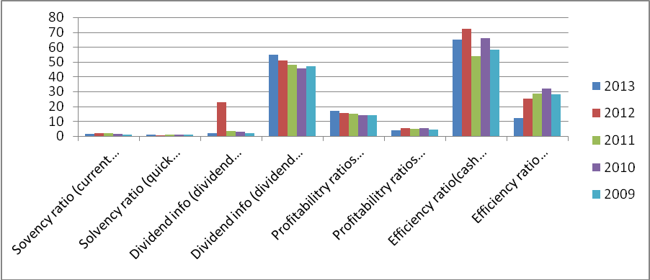
(Source: Author’s Creation)

4. Strategy to increase revenue
The plan is to increase the revenue in the next 5 years. In order to increase the revenue, the company needs to expand its operational base. The increased operational base will lead to market diversification and market penetration. In both instances Durango Manufacturing Company needs extensive infrastructure development. The infrastructure development is a capital intensive operation. Durango Manufacturing Company will invest heavily in the next 5 years with the intention to get profitable returns which will be used in the infrastructure development (Verrecchia, 2001). Apart from that the company has projected the likely cash outflows in the next 5 years. These cash flows will be discounted to find out their most likely value 5 years from now. This is called the capital budgeting process. The choice of appropriate capital budgeting is defended with proper justification.
1. Choice of NPV or IRR in capital budgeting: Capital budgeting is evaluated by the help of discounted cash flow method. Under the discounted cash flow, there are two separate methods. One is the net present value calculation and the other one is the internal rate of return. Both of them are applied in the capital budgeting technique in order to determine the most appropriate one applicable for Durango Manufacturing Company.
2. Determination of the appropriate capital budgeting process: The use of IRR and NPV gives two different kinds of results. NPV indicates that the net value of the cash inflows cannot exceed the total invested amount. The total invested amount is $62484, where as the net cash inflow falls short by $1713. The analysis of IRR indicates a different result. The internal rate of return (IRR) exceeds the required rate of return by almost 5%. This indicates that the IRR is a better choice for analysing the cash flows in comparison to NPV.

5. Recommendations in increasing operational efficiency
Operational efficiency is mainly dependent upon monitoring of 3 very important activities. The 3 important activities are supplier activity, production and manufacturing activity and lastly the packaging and distribution activity (Verrecchia, 2008). Durango Manufacturing Company is suffering from poor operational performance across production and manufacturing activity and packaging and distribution activity.
The production and manufacturing is overloaded with work order and there is no fixed and definite process to categorize the various work orders. The number of orders flowing in is more than the number of orders that can be processed accurately. This is leading to the stagnation of work and poor quality products. The system can be fixed if the company decided to use a job order for each and every work that clearly classifies the jobs that are yet to be started, which are just started, which are already in process and the ones which are completed. This will help to tag each and every job. The central database of the work order status can be linked to the Enterprise Resource Planning System. This will enable Durango Manufacturing Company to know exactly the order delivery date, order delivery address and the urgency of the work order. The company is not able to keep track of the costs incurring across various operations like supply and distribution and other operations like marketing (Vincent, 2007). Most of the time the company ends up allocating funds which either falls short or exceeds the actual requirement. This can be avoided if Durango Manufacturing Company decides to follow activity based costing. The activity based costing allows the company to link the costs in each department with specific activities and operations. Activity costing is related with unit pricing or analyzing the cost for each and every singular activity. This will enable the company to differentiate between relevant and irrelevant costs in a better way.
The activity based costing will help to trace the costs incurred in packaging and distribution of each individual product. For example, sometimes the packaging and distribution activities sometimes involve unnecessary charges in the form of toll tax (Watts, 2004). If a different route is taken involving low toll tax then the costs of distribution will decrease significantly on per product basis. In this way unnecessary costs can also be found out in production and manufacturing operations and eliminated or reduced slowly.

6. Recommendations on outsourcing
The prospect of outsourcing offers abundant opportunity to decrease the manufacturing costs. Outsourcing will help as long as the suppliers who provide the raw materials are adhering to the strict quality control standards as required for the outsourcing agencies. The labour cost in USA is significantly high in comparison to the labour costs in countries like India and China. The hourly wage rate of a worker in USA is almost twice than that of India and even more in comparison to China. Instead of outsourcing all the activities, the less important activities can be outsourced. This provides two different advantages (Wernerfelt, 2005). One is the savings on the cost and the other one is the addition of value. Outsourcing of activities will enable Durango Manufacturing Company with more time and resources to invest for core activities like product development, product innovation and market development.
There are in fact quite a few disadvantages associated with outsourcing. The disadvantages are two types in number. One is the loss of quality control and the other one is the chances of late delivery. Late delivery will hamper the production process. Even if Durango Manufacturing Company decides to outsource the activities which are not mission critical, but late delivery of the lot can derail the work schedule. This will eventually lead to loss of revenue and eventually credibility. Given the fact that Durango Manufacturing Company is on a verge of massive expansion it is best not to take chances that derails the plans of expansion.
The diagram given below presents a illustrative view of the labour costs across different countries. A close comparison reveals that the hourly wage rate of USA is $40/hour. Whereas, the hourly wage rate of countries like India and China is only $5/hour. The difference between the two different types of costs is $40-$5= $35. On one hand, there is significant chance to bring down the costs while on the other hand there is change of non delivery and loss of credibility. Given the delicate situation of the company it is advised not to consider outsourcing of jobs.
Fig 2: Internal labour cost comparison
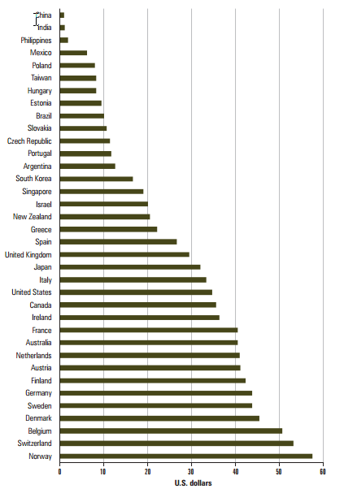
Source: (Wiggins, 2001)
Fig 3: Prediction of the economic and business environment and its impact
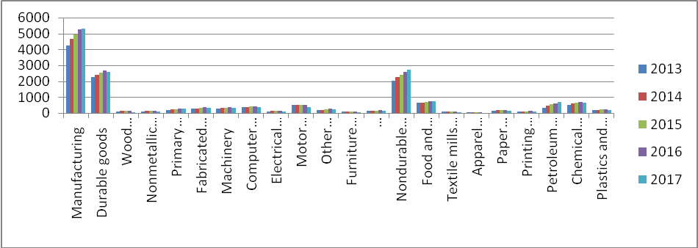
Source: (Wiggins, 2001)
The economic and business environment indicator involves depiction of two separate types of indictors, one is the industrial output projection and another one is the macroeconomic indicators. The macroeconomic indicators are inflation rate, GDP growth rate and prime lending rate. The industrial output will increase at a rate of 5% on an average over the next 5 years (Vincent, 2007). This projection is based on the optimistic view of the macro economic factors. However, if the macro economic factors turn out to be less than optimistic then the industrial output rate will increase by meagre 1.5% per annum. The GDP deflator is going to increase by almost .5% in every two years. The projected GDP will increase by 1.6% for the first two years and only 2% in the next three years. The inflation rate will decrease by 1.5% in every three years (Vincent, 2007).
Fig 4: Macroeconomic indicators
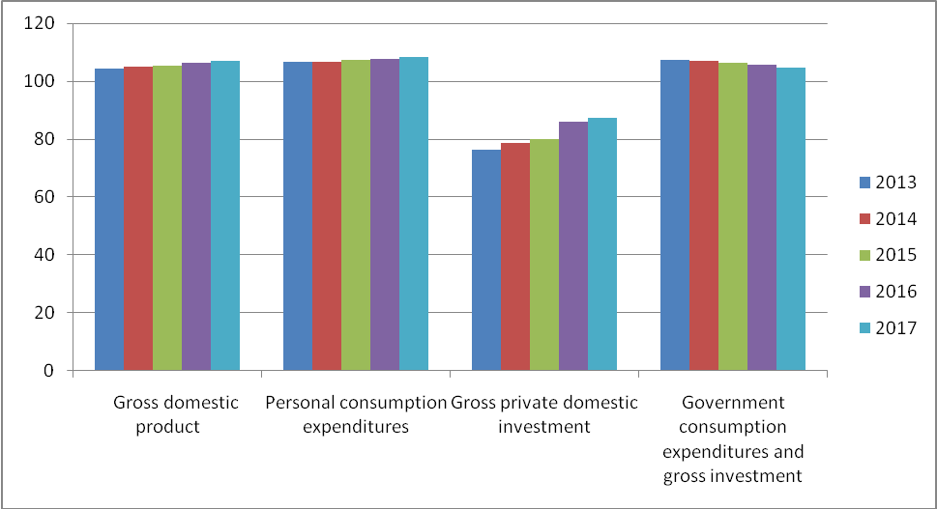
Source: (Verrecchia, 2001)
The current macroeconomic and microeconomic factors indicate that that the industrial output can increase provided the same economic condition is sustained for at least 2 years. Since Durango Manufacturing Company is in manufacturing business, the probability of a good business cycle is as strong as the probability of a weak business cycle for the next years.

7. Recommendations to reach the revenue goals
The diagram below indicates the projected growth in revenue for 5 years. Projected sales revenue increase at 10% each and every year and after end of 5 years the cumulated increase amounts to total of 50%. It is already stated that the company is not in a position to outsource the jobs outside the home country. This also indicates that the plan to increase revenue generation has to be done using the local resources. The company can consider two different kinds of strategy in order to increase the revenue. The first is the Porter’s generic strategy and the second one is the Ansoff’s growth strategy. If the company adopts the Ansoff’s Growth strategy then it can perform both product development and market developments. If the company adopts the Porter’s generic strategy then it will be left with fewer options to perform product development and market diversifications (Vincent, 2007). The choices will narrow down to focused customer strategy. The focused customer strategy can help it develop its product line in accordance to the preferences of the selected customers. This will also help to develop specialization in serving selected customers. Thus, with improved product features and more customization ability, the company will be able to carve a niche market. Niche markets are served with premium quality products, which are priced substantially high. The focused strategy will also help to remove variation in the operational requirements. As the operations begin to fall back in line there will be less variation, less need for adjustment, this will save on costs. So cost leadership on one hand is focused towards segmentation on another hand will help to increase revenue.
Fig 5: Revenue generation
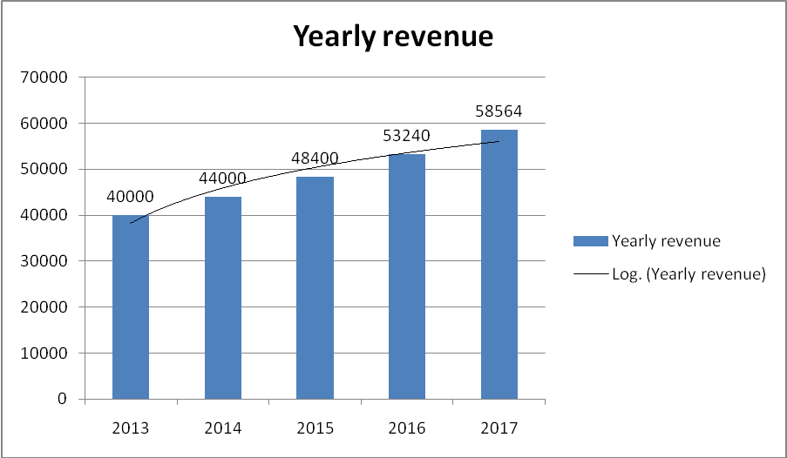
(Source: Author’s Creation)

8. Internal control
For a company as large as Durango Manufacturing Company, it is increasingly difficult to make sure that the activities within and outside the company are carried out with due diligence. This was just the case with Parihar Manufacturing Company. Due to insufficient internal control procedures the management was accused of using internal information for personal benefits. The company did not have any policy that held the managers accountable in the manner internal information can be used (Stigler, 2009). Thus, the management embroiled in unscrupulous uses of sensitive information which led to serious damage both financially and aesthetically. The corporate culture in Parihar Manufacturing Company became infected with malpractices and everybody became impervious to the practices of corruption. The fact was that the employees and the staff knew about the presence of such malpractices but the absence of strong governance and vigilance department limited the power to report such incidents. The situation can be improved with improved corporate governance , clear and transparent financial reporting structure and independent power allotted to an independent body to hold any part accountable for acts of treason and corruption (Stigler, 2009). Improving the corporate culture will be a long and tedious process but this process can be fastened up if the management who committed such fraudulent activities come clean and start the practice of non-tolerance to violence. The employees can be empowered with the ability to report any kind of fraudulent activity if the whistle blowing policies are adopted.
SOX compliance: In order to create an organisation structure that is in full compliance with the Sarbanese Oxley Act, the following different types of amendments need to be made which are:
1. Public Company Accounting Oversight Board is to control the accounting professionals that audit the financial statements of the public companies.
2. The company should be recognised by the SEC.
3. The new board needs to address issues related to the guidance about requirements to register and how to handle people who are related with public accounting firms.
4. There should be proper framework through which corporate governance should be incorporated.

9. IT deficiencies and ways to overcome it
Chances of fraud are quite high for Durango Manufacturing Company since there are large deficiencies in the IT control structure. The lack of IT controls in the company makes it easy for the perpetrators to fudge data and carry out activities which cannot be logged into the system. The need of IT infrastructure is necessary in all the departments starting from the HR department, operations department, financial department, marketing department. The first and foremost task is to implement a comprehensive management information system MIS. The MIS acts as upward and downward feeder for information. The MIS can be divided into 3 distinct stages which are the top or the executive stage, next is the middle management stage and the last in the operational stage (Subramanyam, 2006). The orders come from the executive and the middle management which is carried out by the operational management. The MIS system will help the middle management and the top management to know which operation is carried out in which department and what is the current status of the operation. MIS is a comprehensive IT solution that will create log record of the various activities that goes on around the company in such way that it leaves minimal chance for fraudulent activities. Since Durango Manufacturing Company is a manufacturing industry and involves storing of raw materials and finished products in the warehouses, the company can consider installing close circuit cameras around sensitive areas. Apart from installing a comprehensive MIS system, the company can also install a state of the art ERP system. The ERP system alone can address all the IT problems of the company.

10. Roles and responsibilities of the audit committee member
The current roles and responsibilities of the audit committee is to appoint, oversee and compensate that the independent auditors are retained by the authority as well as approve all kinds of audit services as provided by the independent auditor. The committee for audit shall have power over the engagement, discharge, reimbursement and reviews of the performance of the internal audit director (Teoh, 2003). Apart from that, the other roles and responsibilities are to ensure that the internal audit department of the organization is independent from other kinds of operations of audit.
Fig 6: Audit Committee
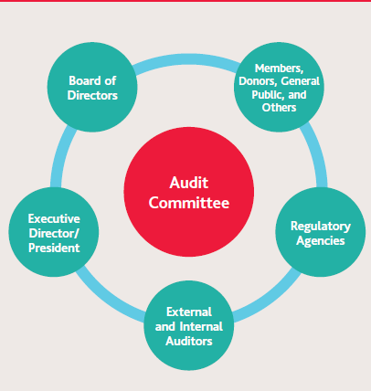
Source: (Teoh, 2003)
The diagram given above is the model of the audit committee that Durango Manufacturing Company can adopt. As the above diagram indicates there are 5 different departments in the audit committees. One is the board of directors. The board of directors will meet as and when required to discuss on various issue regarding the operations of Durango Manufacturing Company. The outcomes of these meetings will be published and notified to the employees and the general public. The regulatory agencies will over look the regulatory aspect of all the departments and make sure that the due diligences are met. The external and the internal auditors will help to prepare annual reports that are in full compliance with the (Generally Accepted Accounting Principles) GAAP principles. This will further help to improve the reporting standards of the company (Verrecchia, 2008). The improved reporting standards will help the company improve the investor confidence. Improve investor confidence will help to attract more investors. Apart from that, there will be executive director or the president of the company.

Reference
Stigler, G. (2009). The theory of economic regulation. The Bell Journal of Economics and Management Science 2.7, 3–21.
Subramanyam, K. (2002). The pricing of discretionary accruals. Journal of Accounting and Economics 22.4, 249–281.
Subramanyam, K. (2006). Uncertain precision and price reaction to information. The Accounting Review 7.1, 207–220.
Teoh, S. (2003). Perceived auditor quality and the earnings response co-eﬃcient. The Accounting Review 6.8, 346–367.
Verrecchia, R. (2001). Essays on disclosure. Journal of Accounting and Economics 3.2, 77-89.
Verrecchia, R. (2008). Discussion of accrual accounting and equity valuation. Journal of Accounting Research Supplement 36.1, 103–115.
Vincent, L. (2007). Equity valuation implications of purchase versus pooling accounting. The Journal of Financial Statement Analysis 2.9, 5–19.
Watts, R. (2004). Accounting choice theory and market-based research in accounting. British Accounting Review 24.5, 235–267.
Wernerfelt, B. (2005). The dynamics of prices and market shares over the product life cycle. Management Science 31.9, 928–939.
Wiggins, R. (2001). The earnings-price and standardized unexpected earnings eﬀects – one anomaly or two. Journal of Financial Research 14.3, 263–275.

